#### Civil Engineering – Example Write-up

#### Company: Central Road Research Institute, New Delhi

#### Faculty: Mahesh Kumar Hamirwasia

##### Amandeep Singh (2012A2PS614P) Discipline: Civil Engineering



The major learning that I acquired in my 5 and half months of exposure at CRRI, one of country’s most prestigious institutes, are twofold. The first was the technical aspect of things and the second was of character building.

The technical aspects include me mastering the statistical software known as IBM SPSS and also acquiring the skill set to tackle the problems relating to Level of service criteria that falls under Traffic Engineering and Safety. Apart from this aspect, the humility I saw in my mentor and his colleagues has left its impression on me and will help me go a long way.

This time period has definitely prepared me for a future in the industrial side of civil engineering. The immediate exposure to real life problems in the industry along with responsibility attached with the work that I conducted has left me with a sense of essionalism and taught me office-work ethics.

The project I was working on determines the level of service of the urban arterial roads in the whole of India. The sheer magnitude of the project appeared daunting at first but over time, under the guidance of Dr. A. Mohan Rao, I learned to focus my problems and solve the problem at hand one step at a time in a swift but organized way. This gave me the confidence that will in the future empower me to tackle any problem at hand. This attitude I feel will be important when I will be responsible for a complete project in the future.

In my time here, I learned how to work alongside other people and learned the true meaning of teamwork and how important colleagues are in an office space. From my seniors I learned the way to guide a person working under me. The way my mentor listened to my doubts and provided me with the right amount of help, not too much but just enough to set me in a path of self discovering the solution.

I would like to round by saying that working at CRRI has left me stronger both cerebrally and spiritually. This has been an experience of a life time and has definitely made a better engineer and a better person.

My major accomplishments include not any medal or certificate but the trust and confidence that my mentor showed in me while doing the work load. My ability to solve the problems in the way advised and also in the time allotted is definitely an accomplishment for me.

#### Chemical Engineering – Example Write-up

#### Company: Aditya Birla Chemicals (Thailand) Ltd.

#### Faculty: Santosh Khandgave

##### Rishab Kapur (2012A4PS276H) Discipline: Mechanical Engineering

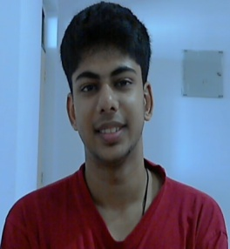

This PS station is unlike any other. Not only because it is in a new country, but also due to the company and work culture. We got to work in a company where you can see both the plant operator and Company President eat beside each other. Where our mentors are not Assistant Managers, but Assistant Vice Presidents, and we interns were given the same respect and treatment as any other employee. Such is the atmosphere there!

Initially when we arrived, we were a little scared and unsure of our role here. But once the projects were assigned and work started, we slowly got comfortable. The best part was that we were not given any kind of spoon feeding. We were taught to expect help only in things related to the plant. No one told us where to find a solution, only that we had to find one. And this was the biggest factor in helping us transition from Academic Learning to Industrial Application.

Working in the projects department in Phosphates Division, we were assigned either old unsolved cases for giving a fresh perspective, or a new problem which needed a solution. When giving our first report, our mentor checked it so thoroughly that it surprised us. That was the time we realized that they were not just keeping us busy, but actually expecting practical solutions from us. This renewed our zeal to work hard for any and every task given to us. The motivation that stems from seeing your work appreciated was greatly felt, especially by the fact that the company was considering implementing our solutions.   
And this was true of all of us. The interns working in the Saraburi plants have achievements to boast of as well. At the Thai Peroxide plant, production has improved by 2 MT/day, and at the Sulphites division, the feasibility analysis for a new product will help them expand into a new 3 Billion $ market. Each of us was also involved with preparations for the 'World Class Manufacturing Awards' assessment, which is an initiative of the Aditya Birla Group. And when our plants won their respective awards, we felt proud to have been able to contribute. As for life outside of the work place, we were living in a completely new and unknown country, where we initially couldn't speak the local language. We had 23 weeks in front of us, and we *lived* them one week at a time. We were part of a good routine which kept us in top mental and physical health. And it is definitely the best thing that happened to us. On the weekends, which we interns spent together, we would explore a new fascinating place, try out some unique and amazing food and gathered memories worth remembering for the rest of our lives. We got a firsthand experience of Thai culture and living, while working in an amazing environment. It really was a dream come true PS for us.

To conclude, I would like to recommend this place as an option for all Mechanical and Chemical Engineering students who want to experience working somewhere you will feel independent and important. Our sincere thanks to PS division and to Aditya Birla Chemicals (Thailand) Ltd. for this opportunity and good luck to the student readers.

#### Electronics Engineering – Example Write-up

#### Company: Nvidia Graphics, Bangalore

#### Faculty: Brajabandhu Mishra

##### Gauri Rajesh Shelat (2012A3PS206G) Discipline: EEE

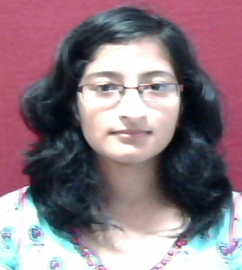

My PS-II station is NVIDIA Bangalore. I have been working here as a part of software development (multimedia) team. Past five months have been an amazing learning opportunity for me. I was introduced to various programming as well as operating systems concepts and was provided with a platform to implement those concepts. Major chunk of my project involved modifying a multimedia framework to incorporate audio playback functionalities. For the implementation of the project, I had to learn various concepts like queues, mutexes, semaphores, buffer pools, multi-threading and some basic knowledge of shared libraries and architecture of a real time operating system called qnx. Apart from this I also learnt various aspects of media processing specific to the audio component of the input stream. These media processing functionalities included de-multiplexing, packet parsing, decoding and rendering of audio stream. As part of another task I have worked on modifying the server to support UDP based media streaming. This task helped me become familiar with basics of networking technologies and socket programming. It also introduced me to various network layers and their respective protocols.

Apart from learning various software related concepts, I have also realized how working in industry is different from academic projects. In industry there is a lot of emphasis on correcting the corner cases associated with a given program. Also, the programs are subjected to large number of stress tests so as to make them as bug-proof and future-proof as possible. The programs are also reviewed by various people to reduce possibility of bugs. Moreover, even while writing a program, a lot of emphasis is laid on making it easy to read, understand and manage. These kinds of programming practices are very typical to industry.

Practice School experience has also helped us become familiar with the required essional attitude and the working environment of companies. We also got an opportunity to interact with and learn from many essionals who already have a lot of experience of working in industry. The constructive feedback from them has helped us in developing new skills as well as refining other skills. Hence Practice school has provided us ample opportunity to implement the techniques learnt in classroom as well as learn new concepts. I sincerely believe that due to this hands-on experience we are now better prepared for the future and experienced gained here will help in smoother transition from academics.

#### Electronics Engineering – Example Write-up

#### Company: Mercedes Benz Research & Development, Bangalore

#### Faculty: S.Raghuraman

##### Jyoti Gautam (2012A4PS347H ) Discipline: Mechanical Engineering

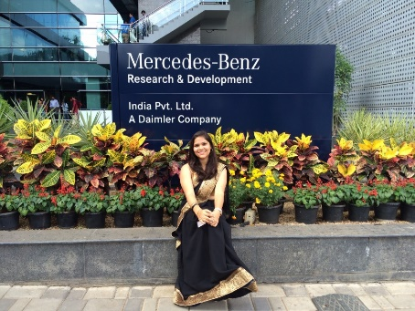

The overall experience at Mercedes Benz Research & Development, Bangalore, India was great and this is what we all should expect out of any PS station. I was not just well trained technically but was also exposed to the high working standards of the company, the very flexible and optimized working condition, highly qualified and experienced employees (including top level managers) with whom I could have meals and share not just my training’s issues but also my day to day happenings. The working hours were flexible 9hrs from Monday to Friday including the mandatory working hours from 10 am- 4pm.

Students from BITS are generally expected to do CAE (Computer Aided Engineering) related work in various teams like CRASH, NVH, OS, Powertrain etc. I worked in Power Train team – Engine Thermo-Mechanical Fatigue Analysis (TMF/A) and was technically trained in three different software- Hypermesh, ABAQUS & Medina. You are not expected to know any software beforehand and sufficient training is provided before your project commences and sometimes the training continues along with the project. I had weekly review meeting with my manager which were very important for the feedback and continuous improvement of my performance. All the employees were very friendly and were ever ready to help me all the possible ways. I even had access to the weekly meetings of the whole team where my suggestions were always welcomed. The company even organized traditional days, plantation drives, road safety week etc. which added more to the experience. So I would say this is a very huge opportunity which will not just add to your resume but also to your life and nobody should miss this.

#### Computer Science – Example Write-up

#### Company: CSR, Bangalore

#### Faculty: Mohammad Saleem Bagewadi

##### Sagar Shah (2012A7PS051H) Discipline: Computer Science

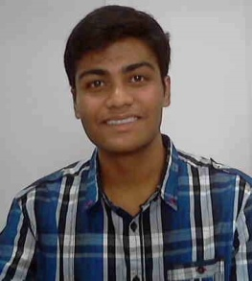

In terms of learning, the experience has been nothing short of terrific. The time spent at PS-2 has been a great teacher in various spheres, including but not limited to understanding corporate life, expert guidance, apprehending new technologies and their developments and building a essional character.

In terms of academics, the training holds a lot of scope on a significant scale. One is expected to learn, work and develop on new technologies applying one’s university education, which is, in itself, a mammoth task to achieve; so much that PS-1 appears to be a joke when compared to its senior and significant counterpart.

For starters, it has made most of us early risers unlike the lazy slobs we were at college. Yes, academic experience is necessary, but the industry is a different ball game altogether; and PS-2 provides a perfect opportunity to learn and acknowledge the differences. It all boils down to deadlines and work, but challenges are interesting too. Employee experience is great; and it helps build the initial industry contact base for future prospects.

Things taught in college are just not enough. The industry is working on feats that are a century ahead of what is taught as academics. Sure, the basics are still the same; but constant learning is not a myth- it’s the very reality we exist in and PS-2 has just been a reminder of the same.

Books, Internet and essional guidance; or expert advice – as you may call it. Recommended books by your team are a necessary read. The initial two weeks in the company are all study no play, but that is exactly what sets a tone for the next five months at office. (In my case, I gorged on Robin Heydon’s “Bluetooth Low Energy”- borrowed it from the company library)

Do not shy away from browsing the internet. The amount of knowledge base on the internet is beyond tremendous and almost every troublesome aspect of books is explained in the simplest of terms. While there was limited material related to my project, the basics were still all there.

Finally, a human touch to all of it is necessary. Helpful mentors make the cut here, and almost all the seemingly unresolved questions find answers with these people. Etiquettes and essional personalities are rarely taught by books and internet.

PS-2 helps one to build their persona, knowledge base and interact with industry experts. The experience at PS-2 - if not affect my future career prospects - has at least made me aware of the current industry standard and situation and that adds to better chances at scoring a workplace.

I have successfully completed one project on template creation of automated generation of tests reducing the workload of testing BLE devices in the company by at least 90%. Also, my other project- Development of automation test framework for BLE devices- is nearing an end and will soon be employed for industry devices.

#### Computer Science – Example Write-up

#### Company: J.P. Morgan Chase., Mumbai

#### Faculty: Krishnamurthy Bindumadhavan

##### Sumir Swarup Kapur (2011B2A2688H) Discipline: Civil

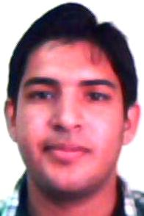

Overall, the experience at JP Morgan Chase, Mumbai has been holistic. It is the perfect place to understand the Back end activities of an Investment Bank and what exactly it takes to serve clients. I can definitely say that this experience has trained me immensely in the skill set, attitude and dedication required to work in corporate life. After working in a firm as huge as JP Morgan, anyone will be able to assimilate with any kind of corporate environment.

I worked in the 'Custody and Fund Services' vertical of Corporate and Investment Banking. My team is a specialized Project Mgmt. team. The work in my team isn't financial research intensive but Financial Operations intensive where we work on a day to day or month to month basis fine tuning business operations or solving crisis driven situations. The work might not be challenging intellectually but requires a great deal of hard work and accuracy.

My team was mostly involved in income related cash flows generated from Equity and Bond markets. Hence, I learned a fair bit of Fixed Income and Equity. In a few tasks, I had to apply concepts of Quantitative methods like Fundamental and Technical Analysis, sampling and various bias like Data Mining, Look forward bias that come with it.

The biggest advantage of working in big Multinational firms like JP Morgan is that you are groomed really well to handle the rigors’ of corporate life. An experience like this will definitely help those who aspire to work in managerial roles in the future. The transition from academic to industry wasn't smooth since on campus, we lead a much laid back, carefree life but industry demands a slightly more intense outlook.

The major take back that I have taken from this internship is that it has widened my knowledge base and awareness of the workings in Investment banking. It will definitely be of a great help in planning my career more pragmatically.

Since, I didn't have an academic background in Finance; it did take me some _me to catch up with financial jargons. But working at JP Morgan has helped me realize my interest in Finance. I plan to do CFA.I have appeared for my CFA Level I examination this Dec.

The PS experience has helped me not only in improving my skill set and knowledge base in Finance but also; create a good network of colleagues and mentors that have guided me immensely in setting my career goals in the field of investment banking.

During my tenure of 5.5 months at JP Morgan, I completed two projects. The impact of the first projects has resulted in a value addition in efficiency by 10%. The other project has helped JP Morgan optimize its Bloomberg expenses reducing the incurred costs in Custody and Fund Services alone by $240000 annually. I have been lauded by my Managing Director and Senior VPs on different occasions for accomplishing these milestones.